**Community Health Needs Assessment**



Nebraska Counties:

Antelope, Boyd, Brown, Cherry, Holt, Keya Paha, Knox, Pierce, and Rock

Table of Contents

Overview of the Comprehensive Community Health Needs Assessment 3

Data Sources 4

NCDHD Comprehensive Health Needs Assessment 5

Policies and Programs 5

Health Factors 5

Physical Environment 6

NCDHD Housing & Transit 6

NCDHD Air & Water Quality 9

NCDHD Social and Economic Factors 10

Education 11

Employment 12

Income 13

Family and Social Support 15

Community Safety 16

NCDHD Clinical Care 20

Access to Care 21

Quality of Care 23

NCDHD Health Behaviors 25

Tobacco Use 25

Diet and Exercise 26

Alcohol and Drug Use 27

Sexual Activity 29

Health Outcomes 32

Length of Life 33

Quality of Life 33

Special Populations 34

Racial and Ethnic Minorities 34

Elderly Population 36

References 37

Overview of the Comprehensive Community Health Needs Assessment

Under the direction of the North Central District Health Department (NCDHD), the 2021 Community Health Needs Assessment has been devised to monitor health status and understand health issues facing the community in the NCDHD. Along with previous assessments, this year’s assessment will serve as a reference document for the health care facilities and community agency partners in the NCDHD to assist in strategic planning and continue working on the Community Health Improvement Plan (CHIP). See pages 11-16 for details.

It is the purpose of this assessment to inform all interested parties about the health status of the population within the Health District and to provide community partners with a wide array of data that can be used to educate and mobilize the community and its resources to improve the health of the population.

The Community Health Needs Assessment process is collaborative and is intended to serve as a single data report for multiple coalitions, organizations, and health care facilities in the Health Department. It is the goal of the Community Health Needs Assessment to describe the health status of the population, identify areas for health improvement, determine factors that contribute to health issues, and identify assets and resources that can be mobilized to address public health improvement. This assessment will be updated and revised every three years, thus providing communities with up-to-date data to evaluate progress made towards identified health priorities and for the selection of new ones.

The University of Nebraska Public Policy Center assembled this assessment of public health and community well-being under the provision of the North Central District Health Department, based largely upon data collected through the process of Mobilizing for Action through Planning and Partnerships (MAPP), behavioral health, and census data.

Data Sources

|  |  |
| --- | --- |
| **Data Source** | **Description** |
| NCDHD Community Health Assessments and Surveys (CHA) | Community surveys conducted by the North Central District Health Department (NCDHD) in 2021 around issues of community well-being. Data from three distinct NCDHD surveys are included: Community Health Assessment, Forces of Change, and the Nebraska Association of Local Health Directors survey. |
| Community Health Rankings (CHR) | The County Health Rankings provide a snapshot of a community’s health and a starting point for investigating and discussing ways to improve health. Information from CHR originates from many sources but are cited from their original source in this report. |
| Behavioral Risk Factor Surveillance System (BRFSS) | A comprehensive, annual health survey of adults ages 18 and on risk factors for many areas impacting public health. This survey was most recently conducted in 2020, though some items are not asked every year. |
| Nebraska Department of Education (NDE) | Data contained in Nebraska's annual State of the Schools Report, including graduation and dropout rates, student characteristics, and student achievement scores. |
| Nebraska Risk and Protective Factor Student Survey (NRPFSS) | A survey of Nebraska youth in grades 8, 10, and 12 on risk and protective factors regarding alcohol, tobacco, and drug use, and bullying, most recently published in 2018. |
| U.S. Census Bureau - American Community Survey (ACS) | U.S. Census Bureau estimates on demographic elements such as population, age, race/ethnicity, household income, poverty, health insurance, and educational attainment. Annual estimates available through the ACS (2015-2019) were used for this report. |
| U.S. Centers for Disease Control and Prevention Web-based Injury Statistics Query and Reporting System (CDC) | CDC’s WISQARS is an interactive, online database that provides fatal and nonfatal injury, violent death, and cost of injury data. |

NCDHD Comprehensive Health Needs Assessment

# Policies and Programs

[INSERT summary of NCDHD CHIP content]

# Health Factors

The County Health Rankings Model provides a holistic structure that identifies factors impacting public health into four categories: Physical Environment, Social and Economic Factors, Clinical Care, and Health Behaviors (CHR, 2021). Studies have previously examined associations between health outcomes and CHR health factor measures and found strong support for the structure and categorizations used in the CHR (Hood et al., 2016; Krause et al., 2021).

Public health professionals have known for some time that the determinants of health are broad, complex, and interact in multiple ways to increase risk and cause illness. An abundance of research indicates that multiple causal connections impact health outcomes (Braveman & Gottlieb, 2014; LaVeist & Pierre, 2014; Viner et al., 2012; Xanthos et al., 2010). In addition to the measures employed by the CHR, the NCDHD Community Health Assessment queried residents about their subjective perceptions of health concerns (Table 1; see Appendix x for qualitative responses for ‘Something else’). The top concerns identified by respondents (*n* = 242) included cancer (65.2%), heart disease (59.5%), mental health (58.7%), lack of exercise (36.7%), and diabetes (36.4%) – all of which are health outcomes driven by multiple factors. Select data is presented below from the measures that compose each of the health factor categories in the CHR model.

Table . *Top Health Concerns of NCDHD CHA Respondents*

|  |  |  |
| --- | --- | --- |
|  | Count | % |
| Cancer | 158 | 65.2 |
| Heart disease | 144 | 59.5 |
| Mental health | 142 | 58.7 |
| Getting enough exercise | 89 | 36.7 |
| Diabetes | 88 | 36.4 |
| Alcohol, Drugs and Tobacco use | 65 | 26.8 |
| Challenges getting healthy and affordable food | 61 | 25.3 |
| Chronic lung disease | 46 | 18.9 |
| Getting around town safely (driving, walking and riding) | 35 | 14.5 |
| Asthma | 34 | 14.4 |
| Something else | 24 | 9.9 |

Functional health literacy, or the ability to read, understand, and act on health information is a crucial skill so that individuals have a grasp of healthcare options and avoid misunderstanding diagnoses, directions for medication administration, and self-care instructions (Andrus & Roth, 2002). When asked if they had trouble reading and understanding health information, 14.4% of NCDHD residents (*n* = 235) reported sometimes or often having trouble.

## Physical Environment

A community’s physical environment refers to where people live, work, learn, and play. Individuals interact with their physical environment through the dwellings in which they live, their means of transportation, the air they breathe, and the water they drink. The quality of these aspects of people’s lives can affect their ability to live healthy, productive lives. The main areas of concern regarding the physical environments within NCDHD stem from some residents reporting severe housing problems and long commutes. Additionally, 69.6% (*n* = 433) of NCDHD residents reported having access to safe places to walk in their neighborhood in 2017, down from the 80.4% (*n* = 518) reported in 2015 (BRFSS, 2020). However, counties within NCDHD have reported overall good air and drinking water quality.

### NCDHD Housing & Transit

The housing options and transit systems that shape a community-built environment affect where its residents live and how they get from place to place. Choices made regarding housing and transportation, as well as underlying opportunities that lead to these choices, also affect community health (CHR, 2021).

#### Housing

Housing has been associated with health via several pathways: home quality and safety, housing affordability and stability, and community resource availability and accessibility. Adequate housing can contribute to good health by protecting individuals and families from harmful exposures as well as by providing them with a sense of privacy, security, stability, and control. In contrast, poor quality and inadequate housing contributes to health problems such as infectious and chronic diseases, injuries, and poor childhood development. Housing measures can also be considered proxy indicators of more general socioeconomic circumstances (Shaw, 2004). Households experiencing severe cost burden have to face difficult trade-offs in meeting other basic needs, such as health insurance, health care and medication, healthy foods, utility bills, or reliable transportation to work or school (Kushel et al., 2006; Ma et.al, 2008; Long, 2003; Levy & DeLeire, 2003). This can then lead to increased emotional strain and stress levels (Hiscock et al., 2001; Dunn, 2000).

As of July 2019, a total of 24,828 housing units were reported within the NCDHD, 74.3% of which are reported as owner-occupied, with a median value of $95,900.00, in which occupants paid a median monthly cost of $1,055.00 (US Census, 2019). Households who reported renting within the NCDHD paid a median gross cost of $630.00 a month. NCDHD residents reported an average of 2.3 persons per household (US Census, 2019). Among the households within NCDHD, 9.0% have reported having severe housing problems such as high housing costs (7.3%), overcrowding (1.2%), or lacking a complete kitchen or plumbing facilities (1.3%; CHR, 2017; Figure 1). Overall, NCDHD (9.0%) reported lower severe housing problems than the U.S. rate (17.5%; *t*(8) = -12.915, *p* < .05) and the Nebraska rate (12.6%; *t*(8) = -5.476, *p* < .05). Brown County (11.2%) reported a significantly higher percentage of severe housing problems than the NCDHD total (9.0%; *t*(8) = 3.351, *p* < .05), and Rock County (4.6%) reported a significantly lower percentage of severe housing problems than the NCDHD total (9.0%; *t*(8) = -6.669, *p* < .05), with all other counties reporting statistically similar percentages to the NCDHD average.

Figure . *Percentage of* *Reported Severe Housing Problems in US, NE, & NCDHD.*

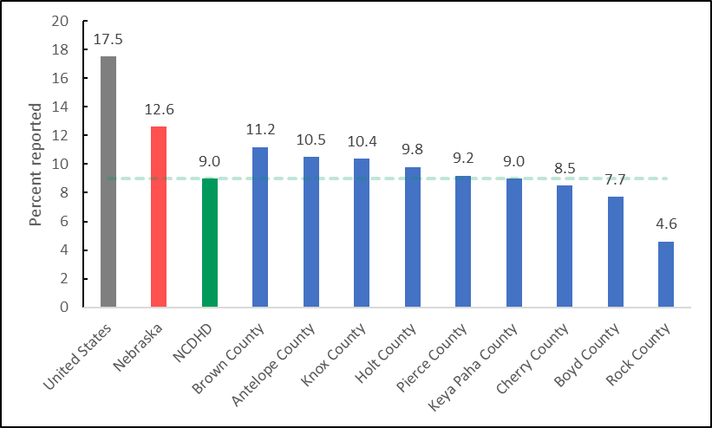

*Note.* NCDHD average line is calculated at 9.0% using CHAS 2013-2017 data.

Access to reliable, high-speed broadband internet can improve access to education, employment, and health care opportunities and is associated with increased economic development (Conroy et al., 2021). Within the NCDHD, 84.5% of households reported having access to a computer, and 76.3% reported having access to at least a broadband internet connection.

#### Public Transit

Public systems such as city buses, sidewalks, bike paths, and highways, as well as cars and bicycles, are included within public transit. However, heavy dependence on individual motorized transit can lead to increased traffic-related accidents and death, air pollution, and physical inactivity and obesity (Robert Wood Johnson Foundation, 2021). Additionally, driving long commutes alone have been associated with poorer mental health outcomes (Künn-Nelen, 2016; Hilbrecht et al., 2014).

According to the American Community Survey (2019) data, 73.0% of NCDHD residents reported that they drive alone to work, with 19.3% of those residents reporting that their commute is longer than 30 minutes (Figure 2). The total percentage of NCDHD residents with long commutes is significantly lower than the U.S.’s (36.6%; *t*(8) = -8.012, *p* < .05) but similar to Nebraska’s total percentage (18.8%; *t*(8) = 0.247, *p* > .05). Three counties reported significantly higher percentages of residents who have long commutes: Keya Paha (28.1%; *t*(8) = 4.068, *p* < .05), Boyd (26.4%; *t*(8) = 3.279, *p* < .05), and Pierce (25.0; *t*(8) = 2.629, *p* < .05).

Figure . *Percentage of Residents with Long Commutes to Work in U.S., NE, & NCDHD*

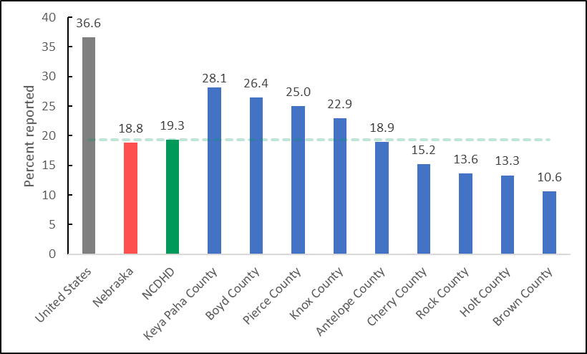

*Note.* NCDHDaverage line is calculated at 19.3% using ACS 2015-2019 data.

### NCDHD Air & Water Quality

Clean air and safe drinking water are essential to community health, as they both support brain health and bodily functions throughout development. The U.S. Environmental Protection Agency (EPA) provides thresholds for six principal pollutants in the National Ambient Air Quality Standards, including particle pollution (PM). Counties within NCDHD appear to enjoy relatively clean air, and have had no reported drinking water violations.

#### Air Quality

Air quality is an important factor to community health, as ambient air pollution has been correlated with decreased lung function, asthma, chronic bronchitis, and other negative pulmonary effects, and long-term exposure to fine particulate matter specifically is linked with premature death risk among those 65 and older (Pope et al., 1995; Di et al., 2017). Air quality is modeled at a county-level as the amount of fine particulate matter (PM2.5) 2.5 microns or less in width per cubic meter (µg/m3), and number of days with ground-level ozone provide the most recently available data, as reported by the CDC's National Environmental Public Health Tracking Program from 2016. PM2.5 thresholds are reported as a three-year average, in which the primary standard of PM2.5 under 12 µg/m3 are considered safe for public health protection, including sensitive populations such as children, the elderly, and people with asthma, while the secondary standard PM2.5 under 15 µg/m3 protects against decreased visibility and damage to animals, crops, vegetation, and buildings. Counties within NCDHD reported average levels of PM2.5 (5.2) that were well below the national threshold of 12, significantly below the national average (7.2; *t*(8) = -7.747, *p* < .05), and similar to the Nebraska average (5.7; *t*(8) = -2.032, *p* > .05). The standard for ozone pollution, otherwise known as “smog”, is 0.08 parts per million, however within NCDHD, only Holt County reported one day of exposure to unhealthy ozone levels in 2016.

#### Water Quality

Poor drinking water has been associated with illnesses such as nausea; lung and skin irritation; cancer; and kidney, liver, and nervous system damage, as well as birth defects and death (Craun et al., 2010; Centers for Disease Control and Prevention, 2019). Water quality is measured by the reported number of drinking water violations per county to the EPA’s Safe Drinking Water Information System (SDWIS) from 2019, which include maximum contaminant level, maximum residual disinfectant level, and treatment technique violations. While Nebraska as a whole has reported drinking water violations in some counties, no counties within NCDHD had any drinking water violations reported in 2019.

## NCDHD Social and Economic Factors

Social and economic factors affect one’s ability to afford housing and medical care, make healthy choices, manage stress, and provide support to others (CHR, 2021) and should be considered when making decisions about how to appropriate resources within communities. These factors include education, employment, income, family and social supports, and community safety. Residents within NCDHD appear to be appropriately educated, be predominately employed, have relatively secure social supports, and enjoy relatively low crime rates. However, household income measures indicate a higher rate of child poverty than the state average, and nearly a third of those surveyed reported making less than a living wage last year. Additionally, accidental injury rates are higher than national and state averages and self-reported safety behaviors are fairly inconsistent.

NCDHD residents also provided some feedback on several areas that they feel are important to their communities (FoC, 2021). When asked about what they thought was important to their community, residents touched on community connection, support, and equality; access to high quality physical and mental healthcare; good school systems; agriculture; supporting community businesses; and retaining the youth in their communities. When asked what made them proud of their community, comments centered around pride in community connection and collaboration.

### Education

Higher levels of education are associated with better employment opportunities, higher incomes, greater sense of control in one’s life, and increased social supports, all of which encourage opportunities for healthy decision-making (Egerton, Braveman, Sadegh-Nobari, & Grossman-Kahn, 2011). Available measures of community education include survey items asking for self-reported highest completed educational level and student perspectives of their school, as well as school district-level language arts and math proficiencies. Overall, the residents of NCDHD appear to be appropriately educated, as the majority of adults who live in NCDHD have reported completing high school and some college; third graders are slightly ahead of their grade levels in reading and math; and the majority of eighth, 10th, and 12th graders report having good grades (mostly A’s and B’s).

#### Adult Education Levels

The overall reported percentage of adults (25 years or older) who have graduated high school in NCDHD (94.7%) is significantly higher than the United States (88.0%; *t*(8) = 13.519, *p* < .05) and Nebraska (91.4%; *t*(8) = 6.607, *p* < .05) average rates (ACS, 2019). Additionally, the rate of adults (25-44 years old) living in NCDHD who reported having completed some college (75.7%) is significantly higher than the United States (66.0%; *t*(8) = 3.458, *p* < .05) rates but similar to the overall Nebraska (72.0%; *t*(8) = 1.314, *p* > .05) rates (ACS, 2019). The reported percentage of adults in NCDHD who report having completed a bachelor’s degree or higher (21.6%), however, is significantly lower than the national (32.1%; *t*(8) = -12.156, *p* < .05) and Nebraska (31.9%; *t*(8) = -11.926, *p* < .05) average rates (ACS, 2019).

#### Youth Education Levels

Student-level data provides another way to assess community education. The average grade level performance for third grade NCDHD students is 3.2 for reading and 3.2 for mathematics (Stanford Education Data Archive, 2018). This indicates that on average, third graders in NCDHD are testing slightly above their grade level in reading and math. The majority of eighth, 10th, and 12th grade students in NCDHD reported receiving mostly A’s or B’s (79.0%), feeling safe at their school (90.8%), and having an adult at school that listens to them (87.7%; NRPFSS, 2018). Graduation rates from school districts within NCDHD (92.3%) are significantly higher than the statewide (88.0%; *t*(13) = 4.142, *p* < .05) student population (NDE, 2021).

### Employment

Gainful employment can provide income and a sense of purpose and belonging and often includes access to health care insurance, paid sick leave, and wellness programs that can encourage healthy choices. Unfortunately, those who are unable to find and maintain gainful employment often are more likely to suffer increased stress, high blood pressure, and greater prevalence of heart disease and depression than those with gainful employment (Braveman, Dekker, et al., 2011; RWJF, 2013).

The unemployment rate in NCDHD (2.9%) is significantly below that of the national average (3.7%; *t*(8) = 6.395, *p* < .05) but similar to Nebraska’s (3.0%; *t*(8) = 1.071, *p* > .05) overall rate (Figure 3). When comparing individual counties within NCDHD, Brown (3.5; *t*(8) = -4.874, *p* < .05) and Boyd (3.3; *t*(8) = -3.353, *p* < .05) counties have higher unemployment rates, while Keya Paha (2.5; *t*(8) = 2.733, *p* < .05) and Cherry (2.4; *t*(8) = 3.493, *p* < .05) counties have lower unemployment rates than the average rate for NCDHD (2.9%; Bureau of Labor Statistics, 2019).

Figure . *Unemployment Rates in U.S., Nebraska, & NCDHD*

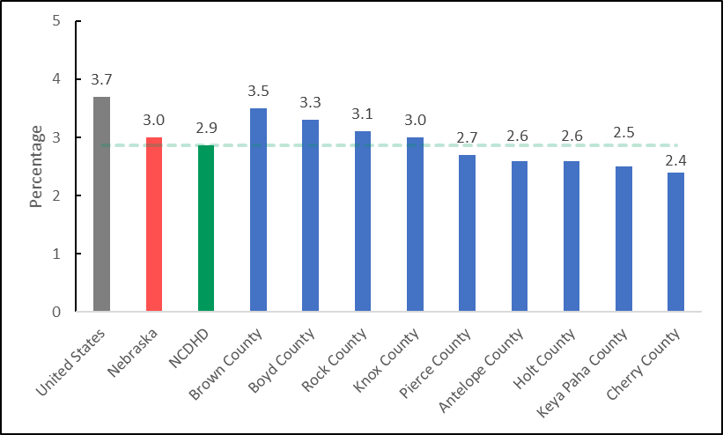

*Note.* NCDHDaverage line is calculated at 2.9% using BLS 2019 data.

### Income

A household’s income level determines what types of health-related choices are available. Those with lower levels of income often have lower access to healthy foods, preventative health care, and educational opportunities and are also associated with poorer physical and mental health outcomes (Braveman, Egerter, & Barclay, 2011). Community income levels can be assessed in terms of percentage of children and households in poverty, income inequality (the ratio of household incomes at the 80th and 20th percentiles), and reported household incomes.

The reported five-year median estimate of NCDHD residents’ household income is $56,250, while their per capita average income is $30,412 (US Census Bureau, 2019). When surveyed about their household income, 31.9% of NCDHD residents (*n* = 185) reported an annual household income at or below a calculated Nebraska average for a living wage (CHA, 2021; Glasmeier, 2020).

According to the US Census Bureau (2019), 12.1% of NCDHD residents and 17.7% of children are estimated to live in households with poverty-level incomes. As seen in Figure 4,the NCDHD estimated percentage of children living in poverty is similar to the national rate (16.8%; *t*(8) = 0.688, *p* > .05) but higher than the Nebraska rate (11.5%; *t*(8) = 4.593, *p* < .05). Estimates of children in poverty for Keya Paha (24.1%; *t*(8) = -4.691, *p* < .05), Boyd (21.9 %; *t*(8) = -3.070, *p* < .05), and Rock (21.1%; *t*(8) = -2.480, *p* < .05) counties are significantly higher than the NCDHD average rate, while Pierce County (10.7%; *t*(8) = 5.182, *p* < .05) is significantly lower.

Figure . *Estimated Children in Poverty Rates for the U.S., NE, & NCDHD*

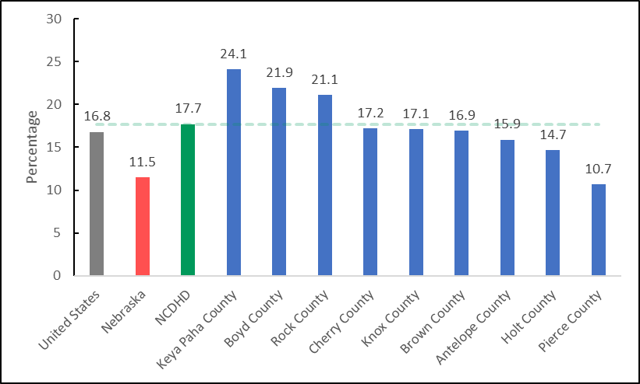

*Note.* NCDHDaverage line is calculated at 17.7% using US Census Bureau 2019 data.

Children within NCDHD (46.3%) who are eligible for free or reduced lunch rates (National Center for Education Statistics, 2019) are on average similar to national (52.0%; *t*(8) = -2.160, *p* > .05) and Nebraska (45.0%; *t*(8) = 0.595, *p* > .05) rates. Boyd (60.0%; *t*(8) = 5.309, *p* < .05) is the only county that has significantly higher rates of free/reduced lunch eligible students than the NCDHD average.

### Family and Social Support

Strong social support systems made up of family, friends, colleagues, and acquaintances provide protective factors for physical and mental health and help to facilitate healthy choices (Kawachi et al., 1999). Individuals who lack adequate social supports can be especially susceptible to stress which is associated with increased cardiovascular issues and unhealthy choices such as overeating and smoking (Egerter, Braveman, & Barclay, 2011).

According to the results of the American Community Survey (2019) 15% of children within NCDHD live in single-parent households, which is associated with adverse mental health outcomes and unhealthy behaviors for children and adults (Balistreri, 2018; Manning, 2015). However, the percentage of children in single-family households in NCDHD (15.0%) is significantly lower than the US average (25.5%; *t*(8) = -5.349, *p* < .05) and the Nebraska average (21.0%; *t*(8) = -3.111, *p* < .05). This result is supported by NCDHD student self-reports, with 14% saying they lived with one parent (NRPFSS, 2018). Students living in the NCDHD also largely agreed that they could ask their parents for help with personal problems (85.4%) and that they had an adult who listens to them at home (86.9%).

The rate of community social associations, as measured by a proxy of county businesses self-reporting the number of membership associations per 10,000 population (County Business Patterns, 2018), in NCDHD (16.7%) is significantly higher than the national rate (9.3%; *t*(8) = 2.959, *p* < .05) and similar to the Nebraska rate (14.0%; *t*(8) = 1.091, *p* > .05). Additionally, 75% (*n* = 12) of NCDHD residents responded affirmatively when asked if there were networks of support for individuals and families during times of stress and need (FoC, 2021). In response to that question, one respondent commented:

“*I believe we could do more to help those that are dealing with behavioral health issues such as depression, grieving, and drug addiction.”*

Residential segregation is defined as the degree to which two or more groups live separately from one another within a geographic area (ACS, 2019). Residential segregation within a community remains prevalent in many areas within the country and is associated with poor health outcomes in areas such as reproductive health, infectious and chronic disease, and increased rates of mortality (Kramer & Hogue, 2009; Bailey et al., 2017). As seen in Figure 5, the average index of racial segregation in NCDHD (27.0) appears lower than the national (46.6) and Nebraska (44.9) indices, but due to a lack of county-level data from several counties, a valid analysis is not available.

Figure . *Racial Segregation Index for U.S., NE, and NCDHD.*

*Note.* NCDHDaverage line is calculated at 27.0 using ACS 2019 data. No data was available for   
Boyd, Brown, Keya Paha, & Rock counties.

### Community Safety

Community safety, which encompasses violent crime, unintentional injuries, and community-level safety behaviors, affects the quality of life for all community members. Community members provided feedback on several key themes for a healthier community.

The violent crime rate within NCDHD, which is measured as the number of violent crimes reported per 100,000 population, is relatively low (88.2) compared to the national (386.5; *t*(7) = -11.299, *p* < .05) and Nebraska (285.7; *t*(7) = -7.729, *p* < .05) rates (Uniform Crime Reporting, 2016). As seen in Figure 6, Cherry County’s (239.7) violent crime rate appears higher than NCDHD’s rate, although due to the lack of data from all counties, these results should be interpreted with caution. No homicides were reported within NCDHD between 2015 and 2019 (National Center for Health Statistics, 2019).

Figure . *Violent Crime Rates for U.S., NE, and NCDHD*

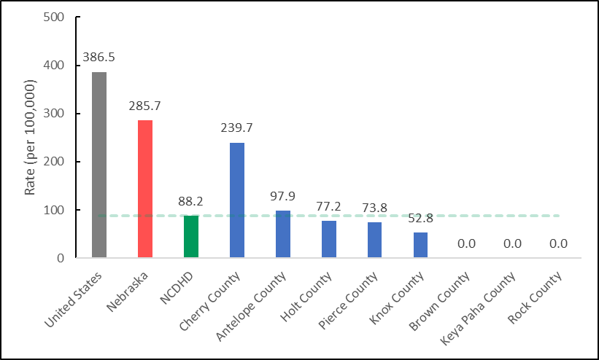

*Note.* NCDHD rate calculated at 88.2 using FBI 2014 & 2016 data. No data was available for   
Boyd County.

Unintentional injury-related deaths are the third leading cause of death in the U.S., the fourth leading cause of death in Nebraska, and the sixth leading cause of death in NCDHD (CDC, 2020). As seen in Figure 7, the rate of injury-related deaths in NCDHD is 89.9 per 100,000 residents (NCHS, 2019). No firearm fatalities were reported within NCDHD between 2015 and 2019 (NCHS, 2019). Analyses were not available due to unreported data from Boyd and Keya Paha counties.

Figure . *Injury-Related Deaths Rates in U.S., NE, and NCDHD*

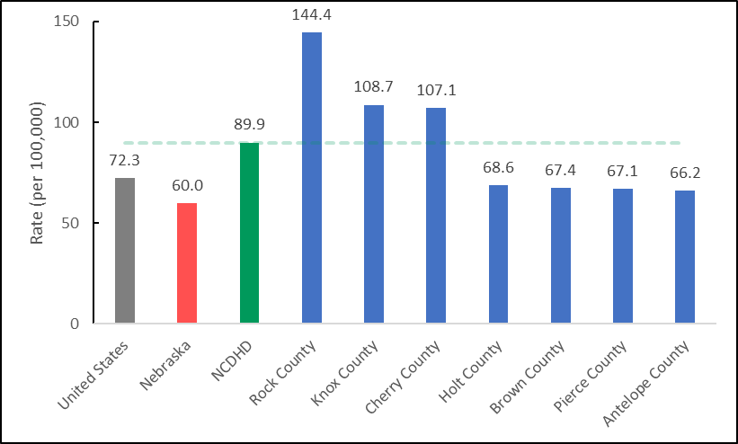

*Note.* NCDHD rate calculated at 89.9 using NCHS 2019 data. No data was available for Boyd and   
Keya Paha counties.

#### Motor Vehicle Safety

Individual-level safety behaviors also contribute to the overall health and sense of well-being within a community. Vehicular safety plays a large role in preventing accidental injuries, which in turn promotes feelings of safety among residents. NCDHD has a rate of 20.0 motor vehicle crash deaths per 100,000 residents (NCHS, 2019). When asked about vehicle safety, only 52.5% (*n* = 727) of NCDHD residents said they always wear a seatbelt while driving or riding in a car, 63.8% (*n* = 379) reported talking on a cell phone while driving in the past 30 days, and 22.9% (*n* = 380) said they had texted while driving in the past 30 days (BRFSS, 2020; BRFSS, 2017). Teenagers also reported talking on their cell phone (*n* = 349; 42.3%) and texting or using an app (*n* = 389; 48.7%) while driving in the past 30 days (NRPFSS, 2018).

#### Student Safety

NCDHD students were asked to self-report on several aspects of safety. The majority of students agreed that they felt safe at their school (*n* = 1001, 90.8%). However, when asked about being bullied, some students reported being bullied physically (*n* = 991; 5.0%), verbally (*n* = 990; 21.9%), socially (*n* = 989; 21.0%), and electronically (*n* = 990; 7.3%) at least once a month in the past year. Additionally, some students also reported being physically hurt on purpose by someone they were dating (*n* = 1001; 5.4%) within the past year.

#### Safety Planning

Safety planning at work and home can help increase preparedness for emergencies, reduce injuries during emergencies, and contribute to an increased sense of safety during non-emergencies. NCDHD residents were asked several questions related to safety planning, and 65% (*n* = 200) reported having a family plan for emergencies, 44.1% (*n* = 213) reported maintaining an emergency preparedness kit at home, 92.0% (*n* = 176) reported having a written emergency action plan at work or school, and 6.1% (*n* = 49) reported that employees or students received training for their emergency action plan within the last year (CHA, 2021).

#### Community Perspectives

NCDHD community members were asked to provide some insight on topics such as what they thought would make their neighborhoods healthier places for them and their families. A wide range of responses (194) were given that were categorized into several themes: increased access to healthy options, increased health education and prevention, and improvements to community spaces.

**Increased access to healthy options.** Many responses focused on increased access to fresh, healthy food options within their communities. This includes better access to grocery stores with fresh food options and more healthy options in their schools, as well as access to better drinking water. This concern is supported by data indicating that 15.3% of NCDHD residents suffer from food insecurity (BRFSS, 2015). Additionally, free or low-cost education and training opportunities were discussed as ways to increase the communities’ healthy options, including training on healthy food options and cooking classes and general community education on health topics. Additionally, respondents noted some community assistance needs, such as help covering costs of necessary home repairs and affordable health insurance.

**Increased health education and prevention.** Several responses espoused a need for increased mental health education regarding resources, stigma, prevention efforts, and better access to resources throughout their community, especially in schools. One participant specified:

*“Recognition that mental health is an integral part of your overall health and needs checked just like your lipids”*

Several other target areas for health education include the negative effects of tobacco, drugs, alcohol use/abuse, and vehicular safety, such as distracted driving, speeding, and traffic sign adherence. Several people commented on the need for increased attention to maintaining healthcare facilities as well as needing more healthcare providers in the area. One respondent also mentioned the need for a decrease in pesticide use throughout the area.

**Improvement of community spaces.** Several types of community area improvements were suggested, including increased spaces for children to play, increased and improved access to sidewalks and general attention to walkability, expansion of walking and biking trails, and better traffic lights. Respondents also mentioned that affordable exercise programs and access to indoor swimming would make their neighborhoods healthier places to live.

## NCDHD Clinical Care

Although advances in medicine and science continue to offer great promise, lack of access to clinical care, and disparities in quality of care provided, continue to serve as critical differentiators that affect outcomes across population groups. Numerous studies indicate that clinical care access and experiences align with health outcome disparities, particularly at the level of socio-economic (Lazar & Davenport, 2018; Riley, 2012) and racial/ethnic group (Cook et al., 2017; Mayberry et al., 2000) differences. In addition to these broad social inequities, systems for healthcare payment also drive access to and quality of clinical care for a wide variety of physical and mental health issues (Fry & Sommers, 2018; Loehrer et al., 2018; Zhao et al., 2018). The CHR model bifurcates clinical care measures into two categories, quality of care, and access to care.

### Access to Care

Regular access to clinical care is critical for illness or disease prevention, management and treatment. Access to care is essential to achieving health equity, but profound barriers exist for many populations (AHRQ, 2021). The CHR employs several broad indicators for access to care. Lack of health insurance coverage prevents many people from obtaining preventative care, and can also be a source of major financial instability. In 2018, an estimated 12% of the NCDHD’s population under age 65 was uninsured, compared to an overall average of 9% for Nebraska. When looking specifically at adults aged 18-64 in the NCDHD area, 13.2% reported not having health insurance, compared to the Nebraska average of 11%. For children under 19 in the NCDHD area, 8.8% are estimated to not have health insurance, compared to a statewide average of 5%. This data suggests that both adult and child residents of the NCDHD area have a lower rate of insurance coverage relative to the rest of Nebraska.

The Community Health Rankings model also contains measures identifying the ratio of health care providers to the overall population. The ratio of the population to number of primary care physicians averaged across counties in the NCDHD was 1,366 persons per primary care provider, compared to an overall statewide average of 1,310 persons per primary care provider. The NCDHD ratio of the population to dentists was 555 to one dentist, compared to an average of 1,270 persons per dentist in Nebraska. Finally, averaged across NCDHD counties, the ratio of the population to mental health providers was 1,903 persons per mental health provider, compared to an overall average of 360 people per mental health provider statewide. It should be noted that all counties which compose the NCDHD are designated as health professional shortage areas by the State of Nebraska for at least one if not all primary medical professions; as well as dentistry, pharmacy and allied health professions (Wehbi et al., 2020). Additionally, every NCDHD county is also a HRSA-designated mental health professional shortage area (HRSA, 2021).

The Nebraska BRFSS asks several questions centering on access to care. According to Nebraska BRFSS 2020 survey results for the NCDHD area, 10% of adults aged 18-64 reported having no health care coverage, whereas 89.9% did. The overall Nebraska average for these survey items were 15.1% and 79.5%. Similarly, 7.8% of NCDHD adults aged 18-64 years old indicated that they needed to see a doctor but could not due to cost in the past year. The Nebraska average was higher, with 9.3% of adults reporting needing to see a doctor but, not being able to due to costs. In terms of having a primary care doctor, 14.3% of adults 18-64 years old indicated they had no personal doctor or health care provider, but 85.7% did. This compares to an overall Nebraska average of 20.5% not having a personal doctor, and 79.5% having a doctor. Among adults within the NCDHD aged 65 or above, 95% had a personal health care provider, or more than one, which is similar to the statewide average of 95%.

Finally, the NCDHD CHA survey, although not representative of the larger population, provides some insight into barriers to accessing clinical care. When asked what problems prevented people from access health screening or services, 49.6% of respondents said there were no barriers. Among those reporting barriers, the top associated problems to accessing care were high costs (15.4%), followed by not knowing when and what kind of services to obtain (11.4%), and not receiving a recommendation from a provider for any screening services (also 11.4%). A major barrier to accessing clinical care is transportation. When it comes to distance needed to travel for clinical care, CHA respondents indicated that distance varied by type of profession or service (Table 2). Distance traveled was less for more common health professionals. For example, 83.3% and 81.4% of NCDHD CHA respondents indicated they lived within 0-30 miles of a primary care provider or pharmacist, respectively. For specialty providers, distances traveled could be much further. Over 33% of respondents indicated they had to travel 75 or more miles to access an oncologist. The availability of specialty care providers in the NCDHD thus remains a significant barrier to some residents.

Table . *Distance in Miles to meet Health Professionals for NCDHD CHA Respondents*

|  |  |  |  |  |  |
| --- | --- | --- | --- | --- | --- |
|  | *n* | 0-30 miles | 31-45 miles | 46-75 miles | 75+ miles |
| Primary Care Professional | 192 | 83.3% | 10.4% | 4.2% | 2.1% |
| Cardiology | 118 | 55.9% | 13.6% | 11% | 19.5% |
| Orthopedic | 111 | 41.4% | 17.1% | 11.7% | 29.7% |
| Urology | 91 | 45.1% | 16.5% | 14.3% | 24.2% |
| Obstetrics/Gynecology | 92 | 39.1% | 20.7% | 17.4% | 22.8% |
| Pediatrician | 74 | 33.8% | 23.0% | 14.9% | 28.4% |
| General surgery | 93 | 49.5% | 17.2% | 15.1% | 18.3% |
| Oncology | 80 | 27.5% | 22.5% | 16.3% | 33.8% |
| Mental Health | 77 | 50.6% | 16.9% | 11.7% | 20.8% |
| Dental Health | 159 | 40.5% | 19.5% | 8.8% | 5.7% |
| Prescriptions/Pharmacy | 156 | 81.4% | 11.5% | 3.8% | 3.2% |
| Other | 38 | 52.6% | 7.9% | 5.3% | 34.2% |

### Quality of Care

Quality of care generally refers to quality screening activities, preventative care, and treatment of acute or chronic conditions to maintain or increase overall wellness and improve health outcomes. Care quality is a broad concept and implicates not only delivery of services to individual consumers, but availability of community health resources and quality and accessibility to health care systems. The CHR model focuses on measures that indicate receipt of timely, preventative services that can decrease health risks and preventable health issues.

The rate of flu vaccinations refers to the percentage of Medicare enrollees that received an annual flu vaccination, based on Medicare reimbursements. Influenza is a common virus that can cause serious illness and death, particularly among medically vulnerable populations. The percentage of fee-for-service Medicare enrollees who received a reimbursed flu vaccine averaged across counties within the NCDHD was 23.1%, significantly lower than the statewide average of 50% (MMD, 2018). This difference speaks to the importance of expanding education about the value and safety of vaccines and identifying opportunities to integrate and provide influenza vaccinations to community members in affordable and accessible ways.

Mammography screenings measure the percentage of female Medicare enrollees that receive an annual mammography. Regular screenings can reduce breast cancer deaths and increase the survival rate among patients and is particularly recommended for females over the age of 45. The percentage of female fee-for-service Medicare enrollees who received a reimbursed flu vaccine averaged across counties within the NCDHD was 43.9%, compared to an overall Nebraska average of 48% (MMD, 2018).

Preventable hospital stays are the rate of hospitalizations per 100,000 Medicare enrollees that are identified as ambulatory-care sensitive conditions (ACSC). These ACSC hospitalizations fall under a wide category of conditions that are generally considered to not require hospitalizations, such as acute diabetes, dehydration, or asthma-related issues (Ansari et al., 2006; Hodgson et al., 2019). Conceptually, researchers have examined and presented elevated rates of preventable hospital stays as an indicator of inadequate access to or low quality or quantity of primary care resources in the community (Freund et al., 2013). In 2018, the number of ACSC hospitalizations per 100,000 Medicare enrollees in the NCDHD was 3,242, lower than the overall average rate for Nebraska of 3,475 (MMD, 2018).

Nebraska BRFSS responses provide some insight into how NCDHD residents experience and perceive information about health or medical issues. When asked how difficult it was for people to get needed advice or information about health or medical topics, 68% of respondents (*n* = 642) thought it was very easy. Additionally, 51% and 52%, respectively, thought it was very easy to understand information from medical professionals, and understand written health information. Ideally, increasing the percentage of people who find it very easy to find, consume and understand health information should remain a priority public health strategy for the foreseeable future.

## NCDHD Health Behaviors

An abundance of research shows that personal health behaviors are strongly linked to chronic disease, mortality, or other outcomes that affect well-being (Berrigan et al., 2003; Hanson & Chen, 2007; Schwarzer, 2008). Cancer, heart disease, diabetes, and other leading causes of death in the United States are strongly associated with unhealthy behaviors that may evolve over a lifetime (Colditz et al., 1992; Keys, 1957; Sasco et al., 2004; Walker et al., 2010). Health professionals play a critical role highlighting behavioral health risks and promoting interventions that encourage communities and individuals to adopt and maintain healthy behaviors across their lifespans. According to Nebraska BRFSS data (2020), 70.5% (*n* = 749) of NCDHD respondents had a routine checkup in the past year with a healthcare provider, 89.7% (*n* = 436) had their blood pressure checked in the past year, 61.5% of female respondents aged 21-65 (*n* = 150) reported up-to-date cervical cancer screenings, and 69.0% of females aged 50-74 (*n* = 230) reported up-to-date breast cancer screenings. Among CHA (2021) survey respondents, 92.7% (*n* = 234) indicated that they had seen a primary care provider once within the previous one to two years, 85.7% (*n* = 231) had seen a dentist, and 83.9% (*n* = 229) had seen an eye doctor. Regularly seeing a healthcare provider and screening for common conditions is an important preventative measure. Particular areas of interest include data on sexual activity, alcohol and drug use, diet and exercise, and tobacco product use.

### Tobacco Use

Tobacco use has historically been one of the top preventable causes of morbidity and death in the United States (CDC, 2012; King et al., 2012). Approximately 480,000 deaths a year are caused by cigarette smoking and secondhand exposure (Gallaway et al., 2018). In the United States, cigarette smoking has become less prevalent from what it was previously. In the 1970s, over 35% of college-educated adults smoked cigarettes, whereas in 2010 that number had declined to less than 10% (Drope et al., 2018). Changes in access and price due to tobacco control policies and the popularity of e-cigarette vaping has considerably altered patterns of tobacco use. Increased vaping among adolescents, and particularly those from low-income or disadvantaged populations, has become a major concern (Dai and Leventhal, 2019; Obisesan et al., 2020).

Nebraska BRFSS data for 2020 indicates that 13.5% of adults in the NCDHD currently smoke cigarettes, and 8.7% use smokeless tobacco. Additionally, 2.3% of adults reported current tobacco vaping, and 14.4% reported vaping tobacco in their lifetimes. Youth responses to the NRPFSS (2018) showed tobacco use that was slightly higher than state averages. For example, among 12th grade respondents 19.6% reported current cigarette or smokeless tobacco use (compared to 15.3% statewide), and 38.9% reported vaping once or more in the past 30 days (compared to 37.3% statewide). Because of the discreet nature of vaping, lower cost compared to cigarettes, and perception that vaping is a “safe” form of tobacco consumption, the illegal use of e-cigarettes has become more prevalent with minors. Among 10th graders, 23.7% of NRPFSS respondents in the NCDHD reported vaping once or more in the past 30 days (compared to 24.7% statewide), and with 8th graders, 8.6% reported vaping in the past 30 days (compared to 10.4% statewide). The continuing prevalence of tobacco consumption – particularly the popularity of vaping products among youth – suggests the need to increase school-based preventive education, tobacco use cessation programming, and other policies to restrict tobacco use and the effects of secondhand smoke.

### Diet and Exercise

Maintaining a healthy diet and regular exercise are key predictors of positive health outcomes. An abundance of evidence links obesity with a wide variety of chronic health conditions, including diabetes, heart disease, stroke, hypertension, cancers, and other illnesses (Hu, 2003; Kelly et al., 2013; Hubbard, 2000; Nejat et al., 2010). Obesity and poor exercise habits are major factors causing preventable chronic diseases and deaths among Americans, resulting in substantially increased individual health care costs and social-economic losses. It should be noted that both obesity and lack of exercise are also impacted by environmental conditions (e.g., costs and availability of healthy food) (Cooksey-Stowers et al., 2017; Walker, Keane & Burke, 2010) and workplace or social and community contexts that promote sedentary lifestyles (Bassett et al., 2015; Gaziano, 2010). It is worth highlighting that the prevalence of obesity and its health impacts in the United States is among the highest in the world, and research indicates strong associations between obesity and race, ethnicity, income, and educational status (Kirby et al., 2012; Lee, 2011; Rossen, 2014).

Nebraska 2020 BRFSS data for the NCDHD indicate that 66.1% (*n* = 702) of respondents reported being either overweight (Body Mass Index >25) or obese, and 32.2% (*n*=702) indicated they were obese (Body Mass Index >30). Forty percent (*n* = 318) of BRFSS respondents eat less than one piece of fruit a day, and 19.4% (n = 774) consumed vegetables less than one time a day. Additionally, 29.3% (*n* = 757) of adult respondents indicated that they had no leisure-time activity in the past 30 days. Again, considerations of poverty and barriers to obtaining healthy food are issues of note. The Community Health Rankings data indicate that an average of 11.9% of respondents across the NCDHD reported not having access to a reliable source of food the previous year, and 16.5% of the low-income population does not live close to a grocery store.

### Alcohol and Drug Use

Alcohol sale and consumption is a widespread fixture of American life. However, excessive use has been linked to a wide range of preventable chronic conditions and acute issues, including a variety of cancers, cardiovascular disorders, and gastrointestinal conditions (Room et al., 2005). Excessive alcohol use is also associated with unintentional and intentional injuries (Chikritzhs and Livingston, 2021; Shield et al., 2012), co-morbidities in mental health (Tembo et al., 2017; Weitzman, 2004), and domestic or relationship aggression and violence (Foran & O’Leary, 2008; Leonard, 2005). Similarly, illegal drug use and addiction is linked to a variety of physical and mental health co-morbidities (Fenton et al., 2012; Jones and McCance-Katz, 2019) and drug overdose related deaths (Lim et al., 2021; Lippold et al., 2019). Studies have indicated that patterns of substance use and associated risk behavior vary by age and geography. For example, alcohol and methamphetamine use is generally higher among rural youth than urban youth (Lambert et al., 2008). Among people aged 12 or older in 2020, marijuana remains the most widely used substance that remains illegal under federal law (49.6 million used in the past year) followed by abuse of prescription drugs (9.3 million used in the past year) (SAMHSA, 2021). SAMHSA estimates that 2.5% of individuals older than 12 years abuse/misuse prescription drugs in Nebraska compared to a national average of 3.7% (SAMHSA, 2020).

According to Nebraska BRFSS data for 2020, 55.5% of adult respondents reported having consumed alcohol in the past 30 days, 20.8% reported binge drinking (4/5 or more drinks on a single occasion for females/males) within the past 30 days, 6.3% reported heavy drinking (8/15 or more drinks in a week for females/males), and 1.5% reported driving under the influence of alcohol. The NCDHD CHA survey indicated that 13.5% (*n* = 193) of respondents reported consuming alcohol more than three times a week, and 11.2% (*n* = 187) reported binge drinking in the past month.

The NRPFSS provides a wider range of data about alcohol and substance use among youth by sampling students from participating public and private school in Grades 8, 10, and 12 from across the state. Among NCDHD youth respondents, 7.2% (*n* = 996) indicated they had consumed alcohol three or more times in the previous month (6.1% statewide), and 26.7% (*n* = 997) indicated it was a little or not wrong to drink alcohol frequently (25.3% statewide). Additionally, 12.0% (*n* = 998) of youth respondents reported that half or more of their peers drank alcohol within the past 30 days (30.7% statewide). Indicators regarding marijuana use suggest a significant prevalence of use among youth. Among youth respondents who reported use of marijuana, 24.6% (*n* = 114) of respondents indicated first use at a mode of 15 years of age. Five percent (*n* = 997) indicated a lifetime use of marijuana of 10 or more times, and 2.9% (*n* = 993) reported using marijuana 3 or more times a week. Among respondents in the NCDHD, 2.9% (*n* = 993) indicated current use of marijuana within the past 30 days compared to a statewide average of 3.9% (NRPFSS, 2018). Additionally, 49.8% (*n* = 987) of youth respondents also indicated that it was easy to obtain alcohol, and 21.1% (*n* = 986) stated it was easy to obtain marijuana. Among those who reported drinking alcohol in the past 30 days, 45.0% (*n* = 211) indicated they accessed alcohol at a party, 25.9% (*n* = 201) indicated they had someone buy it for them, and 22.3% (*n* = 211) got it from home without permission. The prevalence of alcohol and drug use among both adults and youth suggests several possible community strategies, including community education directed to both youth and adults, continued screening and brief intervention processes, and more robust enforcement of laws pertaining to illegal sale or provision of alcohol to minors, such as increased compliance checks and expanded liability for alcohol providers (CHR, 2021).

### Sexual Activity

Research studies indicate disproportionately higher rates of Human Immunodeficiency Virus (HIV) and other sexually transmitted diseases among men who have sex with men (Oster et al., 2011; Prejean et al., 2011), younger people (Rangel et al., 2006), and racial minorities (Maulsby et al., 2014; Wohl et al., 2013). Sexually transmitted infections are associated with reproductive health and other acute and chronic conditions (Owusu-Edusei, 2013). Community Health Rankings data derived from the National Center for HIV/AIDS, Viral Hepatitis, STD, and TB Prevention, indicate that the number of newly diagnosed chlamydia cases per 100,000 population in the NCDHD averaged across counties is 157.9, which, as seen in Figure 8, appears lower than the national (539.9; *t*(5) = -21.313, *p* < .05) and state (418.0; *t*(5) = -14.600, *p* < .05) rates, but due to missing data from several counties, these results should be interpreted with caution (CHR, 2021).

Figure . *Chlamydia Incidence Rate in U.S., NE, & NCDHD*

*Note.* NCDHD rate calculated at 89.9 using National Center for HIV/AIDS, Viral Hepatitis, STD, and  
TB Prevention 2018 data. No data was available for Boyd and Keya Paha counties. No data was   
available from Boyd, Brown, Keya Paha, & Rock counties.

Chlamydia incidence is used as a measure of unsafe sexual activity as it is the most common bacterial sexually transmitted infection in the United States (Community Health Rankings, 2021). Among CHA survey respondents, only 17.1% (*n* = 193) indicated that they had been tested for a Sexually Transmitted Disease (STD) within the previous one to two years, and 61.7% (*n* = 193) indicated that they had never been tested for an STD. Likewise, only 11.4% (*n* = 193) of CHA respondents reported receiving an HIV test within the previous one to two years, and 68.9% (*n* = 193) reported never being tested for HIV. The CHA survey responses reflect Nebraska BRFSS data, which indicate that only an estimated 21.1% (*n* = 396) of adult residents have ever tested for HIV (BRFSS 2020).

Teen pregnancy is often associated with unsafe sexual activity, indicative of increased risk of STIs, and can result in a variety of acute and chronic adverse health conditions (Black et al., 2012; Leve, et al., 2013). Unplanned teen pregnancies can result in significant social costs, with teen mothers being less likely to complete high school and obtain meaningful career training opportunities (Card, 1999; Lavin & Cox, 2012), and contributes to unequal achievement gaps and poverty among young mothers and families later in life (Basch, 2011; Johns, et al., 2000; Tortolero et al., 2010). Teen pregnancy is also associated with underweight or premature births, and a variety of birth defect risks that may impact well-being much later in life (Bornstein et al., 2021; Gill et al., 2012). As seen in Figure 9, Community Health Rankings data derived from the National Center for Health Statistics (2019) indicate that the average number of births to females aged 15-19 across NCDHD counties is 17.9 per 1,000 females, which appears similar to the national (20.9; *t*(5) = -1.093, *p* > .05) and state (19.7; *t*(5) = -0.662, *p* > .05) rates, but due to missing data for several counties, these results should be interpreted with caution.

Figure . *Reported Teen Births in the U.S., NE, and NCDHD*

*Note.* NCDHD rate calculated at 89.9 using National Center for Health Statistics - Natality files   
2019 data. No data was available for Boyd and Keya Paha counties. No data was available from   
Boyd, Keya Paha, & Rock counties.

Preventing unplanned teen pregnancies implicate a number of potential interventions and strategies, including access to pre- and post-natal health care for teen mothers and their children in communities and schools, case management services for young families with income and education needs, and sexual education and reproductive health services in general (Alford, 2009; Kirby, 2001).

# Health Outcomes

Health outcomes represent the overall current health of the community. Health outcomes are driven and influenced by core structural problems related to place, environment, financial insecurity and social inequality. All the structures and influences identified in the County Health Rankings Model drive the health factors that impact community health outcomes. The CHR model presents health outcomes as measures of the overall physical and mental well-being of people. Health outcomes fall in two categories of data: length of life measures, which indicate how long people are living, as well as the prevalence of premature deaths, and quality of life measures, which indicate how healthy people are and feel throughout their lives.

Distinctions exist between NCDHD and Nebraska residents when it comes to length of life. There are similarities among top causes of death but differences in rates of death per 100,000 residents among the major causes. The top three causes of death and rates per 100,000 residents for the NCDHD versus Nebraska, respectively, were heart disease (292.6; 182.9), cancer (223.9; 181.7), and respiratory diseases (81.4; 57.2; CDC, 2020). These rates may reflect differences between older (NCDHD) and younger populations (Nebraska overall). For example, Alzheimer’s disease was the fourth leading cause of death among residents of the NCDHD (65.7) but the sixth leading cause of death among Nebraska residents overall and at a much lower rate of death (38.9).

It should be noted that deaths attributed to COVID-19 in both the NCDHD and Nebraska were lower than in the U.S. overall. In 2020, COVID-19 was the third leading cause of death in the United States (85; CDC, 2020), after heart disease and cancer. COVID-19 was the seventh leading cause of death in both the NCDHD (57.5) and Nebraska (35.2).

## Length of Life

Length of life measures indicate overall length of life among community members relative to others. Length of life can be impacted in a number of ways, and measures employed can identify areas of concern and potential areas for preventative interventions. Premature death refers to Years of Potential Life Lost (YPLL), expressed as the number of years of life lost per 100,000 residents due to deaths before the age of 75 over a three-year period (2017-2019). Statewide YPLL is 6,148.5 years, compared to a slightly higher average of 6768.7 YPLL across the counties composing the NCDHD (excluding Keya Paha County, which did not have reported data). Life expectancy – the average number of years a person is estimated to live – is 79.6 years for Nebraska and 80.1 for the NCDHD (excluding Keya Paha and Rock counties), suggesting approximate parity, *t*(7) = 1.267, *p* > .05 (Figure 10).

Figure . *Life Expectancy in U.S., NE, and NCDHD*

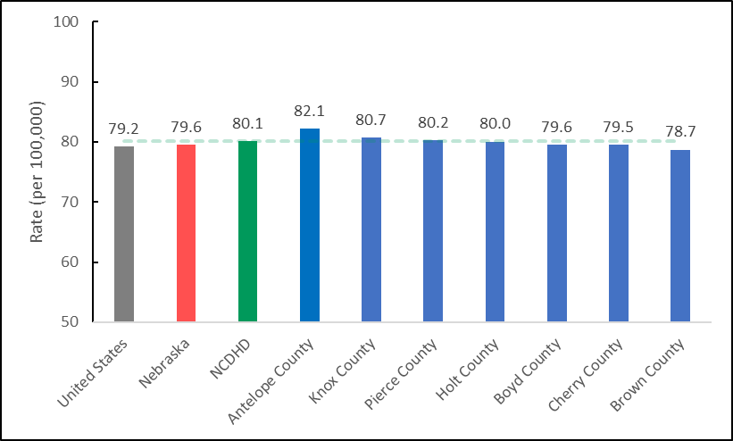

*Note.* Average line calculated as 80.1 using NCHS 2017-2019 data. No data was available for Keya   
Paha and Rock counties.

## Quality of Life

Quality of life is a broad concept that includes overall wellness, subjective experiences and feelings, and day-to-day functioning. The County Health Rankings Model presents quality of life as select measures that reflect the overall health and well-being of people while alive, providing more depth than length of life indicators. Self-reported health-related quality of life is a well-accepted subjective measure that aligns with overall mortality risk measures (CHR, 2021). Averaged across counties, the percentage of adults reporting ‘fair’ or ‘poor’ health in the NCDHD was 14.2%, similar to the state average (13.8%; *t*(8) = 1.054, *p* > .05). The averaged county values (age-adjusted) in the NCDHD for the number of physically unhealthy days reported in the past 30 days was 2.8 days, similar to the statewide average (2.8; BRFSS, 2018). Similarly, averaged county values in the NCDHD for the reported number of mentally unhealthy days in the past 30 days was 2.3 days, while Nebraska average number of days was 3.6 (BRFSS, 2018). Two additional self-reported quality of life measures include frequent physical distress and frequent mental distress, which are more responsive to individuals with chronic or severe physical or mental health conditions. Frequent physical distress is the percentage of adults reporting 14 or more days of poor physical health in the past 30 days, and frequent mental distress is the percentage reporting 14 or more poor mental health days. The averaged values across NCDHD counties was 10.6% for frequent physical distress, and 12.1% for frequent mental distress, compared to overall Nebraska values of 9.6% and 11.3%, respectively (BRFSS, 2018). Additionally, the presence of diabetes is another major quality of life indicator. Diabetes is a common condition, and its high prevalence reflects a number of unhealthy factors and behaviors endemic in society. The CDC (2021) estimates that in 2019, 37 million people of all ages had diabetes in the United States. Averaged across counties, the proportion of adults aged 20 or above with diagnosed diabetes was 11.2% in the NCDHD, and 10% overall in Nebraska (*t*(8) = 2.258, *p* > .05), reflecting relative parity.

# Special Populations

## Racial and Ethnic Minorities

The persistent racial disparities in American health coverage, mental health, chronic health conditions, and mortality are the result of systemic inequalities in housing, economy, and health care, as opposed to individual or group behavior or characteristics (Carralta & Maxwell, 2020). These inequities will require sustainable and deliberate efforts to address societal factors of racial disparities in health. Unfortunately, exploring racial and ethnic disparities in NCDHD is difficult due to lack of identifiable information within the available datasets used for this report. However, available school district data provides information on student and teacher demographics per school district. Racial representation of students can allow teachers of color to act as role models for students of all races and ethnicities by breaking down stereotypes and preparing their students to understand a multiracial society (US Department of Education, 2016). The school districts within NCDHD with available data from NDE (2021) provides a breakdown of student race and ethnicity in relation to their teacher’s race and ethnicity. As seen in Table 3, those who identify as white is the only group with a higher percentage of teachers than percentage of students within the same category. American/Alaskan Indian (6.5%) and Hispanic (6.2%) students are the racial/ethnic groups with the largest disparity between students and teachers. It should be noted that every state has a higher percentage of students of color than teachers of color, so this data should be considered in programming and policy making decisions, rather than as an indictment of the school districts (Boser, 2014).

Table . *Race/Ethnicity Counts of 2021 NCDHD Students and Teachers*

|  |  |  |  |  |  |
| --- | --- | --- | --- | --- | --- |
|  | Student Count | Student % | Teacher Count | Teacher % | Percent Difference |
| American/Alaskan Indian | 478 | 6.5% | 5 | 0.7% | 5.8% |
| Asian | 31 | 0.4% | 0 | 0.0% | 0.4% |
| Black | 38 | 0.5% | 2 | 0.3% | 0.2% |
| Hispanic | 453 | 6.2% | 3 | 0.4% | 5.8% |
| Pacific Islander | 5 | 0.1% | 0 | 0.0% | 0.1% |
| White | 6169 | 84.1% | 681 | 91.4% | -7.3% |
| Multiracial | 162 | 2.2% | 1 | 0.1% | 2.1% |

*Note*. Percent difference is calculated by subtracting the teacher percentage from student percentage in each category.

## Elderly Population

Though many older individuals are in relatively good health and lead active and robust lives, aging increases the likelihood of compound clinical conditions; increased use of multiple medications; and a variety of mobility, sensory, and cognitive impairments (National Research Council, 1996). These types of health outcomes are considered community and national drivers of illness, disability, death, and in turn rising health care costs (CDC, 2022).

The percentage of estimated residents who are 65 and older in NCDHD (25.6%) is significantly higher than that the national (16.5%; *t*(8) = 6.427, *p* < .05) and the Nebraska (16.2%; *t*(8) = 6.638, *p* < .05) estimates (US Census, 2019). The NCDHD CHA (2021) asked respondents if they were 60 years or older (*n* = 216; 30.6%), with a subset of follow-up questions directed at this group. The majority of NCDHD residents who answered these questions reported being in good or better health (88.9%), eating at least two meals a day (92.2%), and said they had enough money to buy the food they needed (95.3%). Only one-fifth of respondents (20.0%) reported having firm plans for long-term care, however. When asked about public services, most of them reported using or planning to use home health (83.3%), retirement planning (77.4%), and legal assistance (73.7%). Roughly half reported using or planning to use volunteer programs (56.9%) and case management (48.2%), and less than half said telephone services (42.2%) or adult day services (42.1%). Additionally, several other questions were explored from the perspectives of 65 years and older NCDHD residents. Their top three health concerns were heart disease (70.4%), cancer (66.7%), and diabetes (51.9%). Most of them reported doing physical activity at least twice a week (95.0%), eating nutritious and balanced meals (88.9%), and reading (70.4%) to maintain their physical and mental health, and about a third of them reported not feeling lonely or disconnected from others (69.6%).

# References

Agency for Healthcare Research and Quality (AHRQ). 2019 National Healthcare Quality and Disparities Report. (2021). *Agency for Healthcare Research and Quality*, Rockville, MD. <https://www.ahrq.gov/research/findings/nhqrdr/nhqdr19/index.html>

Alford, S. (2009). Science and Success: Science-Based Programs that Work to Prevent Teen Pregnancy, HIV & Sexually Transmitted Infections among Hispanics/Latinos. *Advocates for Youth*.

Andrus, M., & Roth. M. (2002). Health literacy: A review. *Pharmacotherapy, 22*(3), 282-302.

Ansari, Z., Laditka, J. N., & Laditka, S. B. (2006). Access to health care and hospitalization for ambulatory care sensitive conditions. *Medical Care Research and Review, 63*(6), 719-741.

Balistreri, S. (2018). Family structure and child food insecurity: Evidence from the current population survey*. Social Indicators Research*, *138*(3), 1171-1185.

Bailey, Z., Krieger, N., Agenor, M., Graves, J., Linos, N., Bassett, M. (2017). Structural racism and health inequities in the USA: Evidence and interventions. *The Lancet, 389*, 1453-1463.

Basch, C. E. (2011). Teen pregnancy and the achievement gap among urban minority youth. *Journal of School Health, 81*(10), 614-618.

Bassett, D. R., John, D., Conger, S. A., Fitzhugh, E. C., & Coe, D. P. (2015). Trends in physical activity and sedentary behaviors of United States youth. *Journal of Physical Activity and Health, 12*(8), 1102-1111.

Berrigan, D., Dodd, K., Troiano, R. P., Krebs-Smith, S. M., & Barbash, R. B. (2003). Patterns of health behavior in US adults. *Preventive Medicine, 36*(5), 615-623.

Black, A. Y., Fleming, N. A., & Rome, E. S. (2012). Pregnancy in adolescents. *Adolescent Medicine: State of the Art Reviews, 23*(1), 123-38.

Bornstein, E., Wasden, S. W., Eliner, Y., Gulersen, M., Lenchner, E., Grunebaum, A., ... & Chervenak, F. (2021). 1026 Teen pregnancy: better definition of the unique sociodemographic and adverse outcomes in this vulnerable population. *American Journal of Obstetrics & Gynecology, 224*(2), S635.

Boser, U. (2014). *Teacher diversity revisited: A new state-by-state analysis.* Center for American Progress.

Braveman, P., Dekker, M., Egerter, S., & Grossman-Kahn, R. (2011). Work, workplaces and health. Princeton: Robert Wood Johnson Foundation. *Exploring the Social Determinants of Health Issue Brief No. 4.*

Braveman, P., Egerter, S., & Barclay, C. (2011). Income, wealth and health. Princeton: Robert Wood J ohnson Foundation. *Exploring the Social Determinants of Health Issue Brief No. 4.*

Braveman, P., Dekker, M., Egerter, S., & Sadegh-Nobari, T. (2011). [Housing and health](http://www.rwjf.org/content/dam/farm/reports/issue_briefs/2011/rwjf70451).Princeton: Robert Wood Johnson Foundation. *Exploring the Social Determinants of Health Issue Brief No. 7.*

Braveman, P., & Gottlieb, L. (2014). The social determinants of health: it's time to consider the causes of the causes. *Public Health Reports, 129*(1_suppl2), 19-31.

Card, J. J. (1999). Teen pregnancy prevention: do any programs work?. *Annual Review of Public Health, 20*(1), 257-285.

Carralta, S., & Maxwell, C. (2020). *Health disparities by race and ethnicity* [Fact Sheet]. Center for American Progress. https://www.americanprogress.org/article/health-disparities-race-ethnicity/

Centers for Disease Control and Prevention. (2021, May 19). Disease & SWS Impact. https://www.cdc.gov/safewater/disease.html

Centers for Medicare & Medicaid Services Office of Minority Health’s Mapping Medicare Disparities (MMD) (2018). Mapping Medicare Disparities Tool [Data set]. Baltimore, MD.

Chikritzhs, T., & Livingston, M. (2021). Alcohol and the Risk of Injury. *Nutrients, 13*(8), 2777. https://doi.org/10.3390/nu13082777

Colditz, G. A., Manson, J. E., Stampfer, M. J., Rosner, B., Willett, W. C., & Speizer, F. E. (1992). Diet and risk of clinical diabetes in women. *The American Journal of Clinical Nutrition, 55*(5), 1018-1023.

Conroy T, Deller S, Kures M, Low S, Glazer J, Huyke G, and Stark C. (2021). Broadband and the Wisconsin Economy. *The Wisconsin Economy Series 7*. University of Wisconsin-Madison, Division of Extension.

Cook, B. L., Trinh, N. H., Li, Z., Hou, S. S. Y., & Progovac, A. M. (2017). Trends in racial-ethnic disparities in access to mental health care, 2004–2012. *Psychiatric Services, 68*(1), 9-16.

Cooksey-Stowers, K., Schwartz, M. B., & Brownell, K. D. (2017). Food swamps predict obesity rates better than food deserts in the United States. *International Journal of Environmental Research and Public Health*, *14*(11), 1366.

County Health Rankings. (2021). *County Health Rankings National Data.* (2021) [Data set]. <https://www.countyhealthrankings.org/explore-health-rankings/rankings-data-documentation>

Craun, G., Brunkard, J., Yoder, J., Roberts, V., Carpenter, J., Wade, T., Calderon, R., Roberts, J., Beach, M., & Roy, S. (2010). Causes of Outbreaks Associated with Drinking Water in the United States from 1971 to 2006. *Clinical Microbiology Reviews, 23*(3), 507-528. <https://doi.org/10.1128/CMR.00077-09>

Croft, M., Hayes, S., & Moore, R. (2020). *Supporting the mental health well-being of high school students.* ACT Center for Equity in Learning. https://www.act.org/content/dam/act/unsecured/ documents /R1798-mental-health-2020-01.pdf

Dai, H., & Leventhal, A. M. (2019). Prevalence of e-cigarette use among adults in the United States, 2014-2018. *JAMA, 322*(18), 1824-1827.

Dai, H., Saccardo, S., Han, M.A. et al. Behavioural nudges increase COVID-19 vaccinations*. Nature* 597, 404–409 (2021). https://doi.org/10.1038/s41586-021-03843-2

Di, Q., Wang, Y., Zanobetti, A., Wang, Y., Koutrakis, P., Choirat, C., Dominici, F., & Schwartz, J. (2017). Air pollution and mortality in the Medicare population. *New England Journal of Medicine, 376*, 2513-2522. doi: 10.1056/NEJMoa1702747.

Drope, J., Liber, A. C., Cahn, Z., Stoklosa, M., Kennedy, R., Douglas, C. E., ... & Drope, J. (2018). Who's still smoking? Disparities in adult cigarette smoking prevalence in the United States. *CA: A Cancer Journal for Clinicians, 68*(2), 106-115.

Dunn, J. R. (2000). Housing and health inequalities: Review and prospects for research. *Housing Studies, 15*(3), 341-366.

Egerton, S., Braveman, P., & Barclay, C. (2011). *Exploring the social determinants of health* (Issue Brief No. 3). Princeton: Robert Wood Johnson Foundation.

Egerton, S., Braveman, P., Sadegh-Nobari, T., & Grossman-Kahn, R. (2011). *Exploring the social determinants of health* (Issue Brief No. 5). Princeton: Robert Wood Johnson Foundation.

Fenton, M. C., Keyes, K., Geier, T., Greenstein, E., Skodol, A., Krueger, B., ... & Hasin, D. S. (2012). Psychiatric comorbidity and the persistence of drug use disorders in the United States. *Addiction, 107*(3), 599-609.

Foran, H. M., & O'Leary, K. D. (2008). Alcohol and intimate partner violence: A meta-analytic review. *Clinical Psychology Review, 28*(7), 1222-1234.

Freund, T., Campbell, S. M., Geissler, S., Kunz, C. U., Mahler, C., Peters-Klimm, F., & Szecsenyi, J. (2013). Strategies for reducing potentially avoidable hospitalizations for ambulatory care–sensitive conditions. *The Annals of Family Medicine, 11*(4), 363-370.

Fry, C. E., & Sommers, B. D. (2018). Effect of Medicaid expansion on health insurance coverage and access to care among adults with depression. *Psychiatric Services, 69*(11), 1146-1152.

Gallaway, M. S., Henley, S. J., Steele, C. B., Momin, B., Thomas, C. C., Jamal, A., ... & Stewart, S. L. (2018). Surveillance for cancers associated with tobacco use—United States, 2010–2014. *MMWR Surveillance Summaries, 67*(12), 1.

Gaziano, J. M. (2010). Fifth phase of the epidemiologic transition: The age of obesity and inactivity. *JAMA, 303*(3), 275-276.

Gill, S. K., Broussard, C., Devine, O., Green, R. F., Rasmussen, S. A., Reefhuis, J., & National Birth Defects Prevention Study. (2012). Association between maternal age and birth defects of unknown etiology―United States, 1997–2007. *Birth Defects Research Part A: Clinical and Molecular Teratology, 94*(12), 1010-1018.

Glasmeier, A. (2020). *Living wage calculator.* Massachusetts Institute of Technology. <https://livingwage.mit.edu>.

Hall, H. I., Song, R., Tang, T., An, Q., Prejean, J., Dietz, P., ... & Mermin, J. (2017). HIV trends in the United States: diagnoses and estimated incidence. *JMIR Public Health and Surveillance, 3*(1), e7051.

Hanson, M. D., & Chen, E. (2007). Socioeconomic status and health behaviors in adolescence: a review of the literature. *Journal of Behavioral Medicine, 30*(3), 263-285.

Health Resources and Services Administration (HRSA). (n.d.). *Find shortage areas, HRSA find*. Retrieved Feb. 18, 2021 from [https://data.hrsa.gov/tools/shortage-area](https://data.hrsa.gov/tools/shortage-area%20)

Hilbrecht, Smale, & Mock. (2014). Highway to health? Commute times and well-being among Canadian adults. *World Leisure Journal, 56*(2), 151-163. <https://doi.org/10.1080/16078055.2014.903723>

Hiscock, R., Kearns, A., MacIntyre, S., & Ellaway, A. (2001). Ontological security and psycho-social benefits from the home: Qualitative evidence on issues of tenure. *Housing, Theory and Society, 18*(1-2), 50-66.

Hood, C. M., Gennuso, K. P., Swain, G. R., & Catlin, B. B. (2016). County health rankings: relationships between determinant factors and health outcomes. *American Journal of Preventive Medicine*, *50*(2), 129-135.

Hodgson, K., Deeny, S. R., & Steventon, A. (2019). Ambulatory care-sensitive conditions: Their potential uses and limitations. *BMJ Quality & Safety, 28*(6), 429-433.

Hu, F. B. (2003). Overweight and obesity in women: health risks and consequences. *Journal of Women's Health*, *12*(2), 163-172.

Johns Hopkins University School of Medicine, Coronavirus Resource Center (JHU) (2021). Nebraska. Retrieved Feb. 15, 2022 at <https://coronavirus.jhu.edu/region/us/nebraska>

Johns, M. J., Moncloa, F., & Gong, E. J. (2000). Teen pregnancy prevention programs: Linking research and practice. *Journal of Extension, 38*(4), 1-9.

Jones, C. M., & McCance-Katz, E. F. (2019). Co-occurring substance use and mental disorders among adults with opioid use disorder. *Drug and Alcohol Dependence, 197*, 78-82.

Kawachi, I., Bruce, P., Glass, R. (1999). Social capital and self-rated health: A contextual analysis. *American Journal of Public Health, 89*, 1187-1193.

Keys, A. (1957). Diet and the epidemiology of coronary heart disease. *Journal of the American Medical Association, 164*(17), 1912-1919.

Key, J. D., Gebregziabher, M. G., Marsh, L. D., & O’Rourke, K. M. (2008). Effectiveness of an intensive, school-based intervention for teen mothers. *Journal of Adolescent Health, 42*(4), 394-400.

Kim, D. D., & Basu, A. (2016). Estimating the medical care costs of obesity in the United States: systematic review, meta-analysis, and empirical analysis. *Value in Health*, *19*(5), 602-613.

King, B. A., Dube, S. R., & Tynan, M. A. (2012). Current tobacco use among adults in the United States: findings from the National Adult Tobacco Survey. *American Journal of Public Health*, *102*(11), e93-e100.

Kirby, D. (2001). Emerging answers: Research findings on programs to reduce teen pregnancy (summary). *American Journal of Health Education, 32*(6), 348-355.

Koniak‐Griffin, D., Lesser, J., Uman, G., & Nyamathi, A. (2003). Teen pregnancy, motherhood, and unprotected sexual activity. *Research in Nursing & Health, 26*(1), 4-19.

Kramer, M., & Hogue, C. (2009). Is segregation bad for your health? *Epidemiology, 31*, 178-194.

Krause, T. M., Schaefer, C., & Highfield, L. (2021). The association of social determinants of health with health outcomes. *American Journal of Managed Care*, *27*(3), e89-e96.

Künn-Nelen, A. (2016). Does commuting affect health? *Health Economics, 25*(8), 984–1004. https://doi.org/10.1002/hec.3199

Kushel, M. B., Gupta, R., Gee, L., & Haas, J. S. (2006). Housing instability and food insecurity as barriers to health care among low-income Americans. *Journal of General Internal Medicine, 21*(1), 71-77.

Lambert, D., Gale, J.A., & Hartley, D. (2008). Substance abuse by youth and young adults in rural America. *Journal of Rural Health, 2008 Summer*, 24(3):221-8. doi: 10.1111/j.1748-0361.2008.00162.x. PMID: 18643798.

LaVeist, T. A., & Pierre, G. (2014). Integrating the 3Ds—social determinants, health disparities, and health-care workforce diversity. *Public Health Reports, 129* (1_suppl2), 9-14.

Lavin, C., & Cox, J. E. (2012). Teen pregnancy prevention: current perspectives. *Current Opinion in Pediatrics*, *24*(4), 462-469.

Lazar, M., & Davenport, L. (2018). Barriers to health care access for low income families: a review of literature. *Journal of Community Health Nursing, 35*(1), 28-37.

Leonard, K. E. (2005). Alcohol and intimate partner violence: when can we say that heavy drinking is a contributing cause of violence?. *Addiction, 100*, 422-425.

Lee, H. (2011). Inequality as an explanation for obesity in the United States. *Sociology Compass, 5*(3), 215-232.

Leve, L. D., Kerr, D. C., & Harold, G. T. (2013). Young adult outcomes associated with teen pregnancy among high-risk girls in a randomized controlled trial of multidimensional treatment foster care. *Journal of Child & Adolescent Substance Abuse, 22*(5), 421-434.

Levy, H., & DeLeire, T. (2003). What do people buy when they don't buy health insurance and what does that say about why they are uninsured? *National Bureau of Economic Research.*

Lim, J. K., Earlywine, J. J., Bagley, S. M., Marshall, B. D., & Hadland, S. E. (2021). Polysubstance involvement in opioid overdose deaths in adolescents and young adults, 1999-2018. *JAMA Pediatrics, 175*(2), 194-196.

Lippold, K. M., Jones, C. M., Olsen, E. O. M., & Giroir, B. P. (2019). Racial/ethnic and age group differences in opioid and synthetic opioid–involved overdose deaths among adults aged≥ 18 years in metropolitan areas—United States, 2015–2017. *Morbidity and Mortality Weekly Report, 68*(43), 967-973.

Loehrer, A. P., Chang, D. C., Scott, J. W., Hutter, M. M., Patel, V. I., Lee, J. E., & Sommers, B. D. (2018). Association of the Affordable Care Act Medicaid expansion with access to and quality of care for surgical conditions. *JAMA Surgery, 153*(3), e175568-e175568.

Long, S. K. (2003). Hardship among the uninsured: choosing among food, housing, and health insurance.

Ma, C. T., Gee, L., & Kushel, M. B. (2008). Associations between housing instability and food insecurity with health care access in low-income children. *Ambulatory Pediatrics, 8*(1), 50-57.

Mayberry, R. M., Mili, F., & Ofili, E. (2000). Racial and ethnic differences in access to medical care. *Medical Care Research and Review, 57*(1_suppl), 108-145.

Manning, W. (2015). Cohabitation and child wellbeing. *The Future of Children, 25*(2).

Maulsby, C., Millett, G., Lindsey, K., Kelley, R., Johnson, K., Montoya, D., & Holtgrave, D. (2014). HIV among black men who have sex with men (MSM) in the United States: A review of the literature. *AIDS and Behavior, 18*(1), 10-25.

National Research Council (US) Committee to Develop an Agenda for Health Outcomes Research for Elderly People. (1996). *Health outcomes for older people: Questions for the coming decade.* Feasley, J. (Ed.), National Academy Press, Washington D.C.

Nejat, E. J., Polotsky, A. J., & Pal, L. (2010). Predictors of chronic disease at midlife and beyond-the health risks of obesity. *Maturitas, 65*(2), 106-111.

Obisesan, O. H., Osei, A. D., Uddin, S. I., Dzaye, O., Mirbolouk, M., Stokes, A., & Blaha, M. J. (2020). Trends in e-cigarette use in adults in the United States, 2016-2018. *JAMA Internal Medicine, 180*(10), 1394-1398.

Oster, A. M., Wiegand, R. E., Sionean, C., Miles, I. J., Thomas, P. E., Melendez-Morales, L., ... & Millett, G. A. (2011). Understanding disparities in HIV infection between black and white MSM in the United States. *AIDS, 25*(8), 1103-1112.

Owusu-Edusei, K., Chesson, H. W., Gift, T. L., Tao, G., Mahajan, R., Ocfemia, M. C. B., & Kent, C. K. (2013). The estimated direct medical cost of selected sexually transmitted infections in the United States, 2008. *Sexually Transmitted Diseases, 40*(3), 197-201.

Pope, C., Dockery, D., & Schwartz, J. (1995). Review of epidemiological evidence of health effects of particulate air pollution. *Inhalation Toxicology*, *7*(1), 1-18. <https://doi.org/10.3109/08958379509014267>

Prejean, J., Song, R., Hernandez, A., Ziebell, R., Green, T., Walker, F., ... & HIV Incidence Surveillance Group. (2011). Estimated HIV incidence in the United States, 2006–2009. *PloS one, 6*(8), e17502.

Rangel, M. C., Gavin, L., Reed, C., Fowler, M. G., & Lee, L. M. (2006). Epidemiology of HIV and AIDS among adolescents and young adults in the United States. *Journal of Adolescent Health, 39*(2), 156-163.

Rehm, J. (2011). The risks associated with alcohol use and alcoholism. *Alcohol Research & Health, 34*(2), 135-143.

Rehm, J., & Shield, K. D. (2010). Alcohol and mortality. *Global alcohol-attributable deaths from cancer, liver cirrhosis, and injury in*, 174-183.

Riley, W. J. (2012). Health disparities: Gaps in access, quality and affordability of medical care. *Transactions of the American Clinical and Climatological Association, 123*, 167-174.

Robert Wood Johnson Foundation. (2012).[How does transportation impact health?](http://www.rwjf.org/content/dam/farm/reports/issue_briefs/2012/rwjf402311) *Health Policy Snapshot Public Health and Prevention Issue Brief.*

Robert Wood Johnson Foundation. (2013).[How does employment – or unemployment – affect health?](http://www.rwjf.org/content/dam/farm/reports/issue_briefs/2012/rwjf402311) *Health Policy Snapshot Public Health and Prevention Issue Brief.*

Room, R., Babor, T., & Rehm, J. (2005). Alcohol and public health. *The Lancet*, *365*(9458), 519-530.

Rossen, L. M. (2014). Neighbourhood economic deprivation explains racial/ethnic disparities in overweight and obesity among children and adolescents in the USA. *Journal of Epidemiology and Community Health, 68*(2), 123-129.

Sasco, A. J., Secretan, M. B., & Straif, K. (2004). Tobacco smoking and cancer: a brief review of recent epidemiological evidence. *Lung Cancer, 45*, S3-S9.

Schwarzer, R. (2008). Modeling health behavior change: How to predict and modify the adoption and maintenance of health behaviors. *Applied Psychology, 57*(1), 1-29.

Shaw, M. (2004). *Housing and public health. Annu. Rev. Public Health, 25*, 397-418.

Shield, K. D., Gmel, G., Patra, J., & Rehm, J. (2012). Global burden of injuries attributable to alcohol consumption in 2004: a novel way of calculating the burden of injuries attributable to alcohol consumption. *Population Health Metrics, 10*(1), 1-14.

Substance Abuse and Mental Health Services Administration (SAMHSA). (2021). *Key substance use and mental health indicators in the United States: Results from the 2020 National Survey on Drug Use and Health* (HHS Publication No. PEP21-07-01-003, NSDUH Series H-56). Rockville, MD: Center for Behavioral Health Statistics and Quality, Substance Abuse and Mental Health Services Administration. Retrieved from https://www.samhsa.gov/data/

Substance Abuse and Mental Health Services Administration (SAMHSA). (2020). Behavioral Health Barometer: Nebraska, Volume 6: Indicators as measured through the 2019 National Survey on Drug Use and Health and the National Survey of Substance Abuse Treatment Services. HHS Publication No. SMA–20–Baro–19–NE. Rockville, MD: Substance Abuse and Mental Health Services Administration, 2020.

Tembo, C., Burns, S., & Kalembo, F. (2017). The association between levels of alcohol consumption and mental health problems and academic performance among young university students. *PLoS One, 12*(6), e0178142.

Tortolero, S. R., Hernandez, B. F., Cuccaro, P. M., Peskin, M. F., Markham, C. M., & Shegog, R. (2010). Latino Teen Pregnancy in Texas: Prevalence, Prevention, and Policy. *Journal of Applied Research on Children, 1*(1), 5.

U.S. Centers for Disease Control and Prevention (CDC). (2012). Current cigarette smoking among adults-United States, 2011. *MMWR. Morbidity and mortality weekly report*, *61*(44), 889-894.

U.S. Centers for Disease Control (CDC) (2020). Mortality in the United States, 2020: What are the death rates for the 10 leading causes of death? (NCHS Data Brief No. 427, December 2021). https://www.cdc.gov/nchs/products/databriefs/db427.htm#section_4

U.S. Centers for Disease Control (CDC) (2021). Prevalence of both diagnosed and undiagnosed diabetes. https://www.cdc.gov/diabetes/data/statistics-report/diagnosed-undiagnosed-diabetes.html

U.S. Department of Education. (2016). *The state of racial diversity in the educator workforce.* Office of Planning, Evaluation, and Policy Development. Washington, D.C.

U.S. Department of Transportation, Federal Highway Administration, (2011). [*Summary of Travel Trends: 2009 National Household Travel Survey*](http://nhts.ornl.gov/2009/pub/stt.pdf)*.*

Viner, R. M., Ozer, E. M., Denny, S., Marmot, M., Resnick, M., Fatusi, A., & Currie, C. (2012). Adolescence and the social determinants of health. *The Lancet, 379*(9826), 1641-1652.

Walker, R. E., Keane, C. R., & Burke, J. G. (2010). Disparities and access to healthy food in the United States: A review of food deserts literature. *Health & Place, 16*(5), 876-884.

Walker, K. Z., O’Dea, K., Gomez, M., Girgis, S., & Colagiuri, R. (2010). Diet and exercise in the prevention of diabetes. *Journal of Human Nutrition and Dietetics, 23*(4), 344-352.

Wehbi, N., Mosalpuria, K., Deras, M., Palm, D., Wilson, F., and Carritt, N. (2020*). The status of the Nebraska healthcare workforce: 2020 update*. Omaha, NE: UNMC Center for Health Policy. https://www.unmc.edu/publichealth/chp/_documents/Workforce_2020.pdf

Weitzman, E. R. (2004). Poor mental health, depression, and associations with alcohol consumption, harm, and abuse in a national sample of young adults in college. *The Journal of Nervous and Mental Disease, 192*(4), 269-277.

Wilson, C. M., Wright, P. F., Safrit, J. T., & Rudy, B. (2010). Epidemiology of HIV infection and risk in adolescents and youth. *Journal of Acquired Immune Deficiency Syndromes*, *54*(Suppl 1). doi:10.1097/QAI.0b013e3181e243a1

Windels, K. (2011). What’s in a number? Minority status and implications for creative professionals. *Creative Research Journal, 23*(4), 231-329. doi: 10.1080/10400419.2011.621820

Wohl, A. R., Galvan, F. H., Carlos, J. A., Myers, H. F., Garland, W., Witt, M. D., ... & George, S. (2013). A comparison of MSM stigma, HIV stigma and depression in HIV-positive Latino and African American men who have sex with men (MSM). *AIDS and Behavior, 17*(4), 1454-1464.

Xanthos, C., Treadwell, H. M., & Holden, K. B. (2010). Social determinants of health among African–American men. *Journal of Men's Health, 7*(1), 11-19.

Zhao, G., Okoro, C. A., Li, J., & Town, M. (2018). Health insurance status and clinical cancer screenings among US adults. *American Journal of Preventive Medicine, 54*(1), e11-e19.